CSE471 

System analysis and design

Final Project Report

Section: 06

Title of the project : Restaurant Loyalty System

Group Name: 360 Noscopers

***Group members:***

|  |  |  |
| --- | --- | --- |
| ***Sl.*** | ***ID*** | ***Name*** |
| 1. | 17101056 | S.M. Nabil Ashraf |
| 2. | 17101079 | Rizwanul Hoque Ratul |

**Introduction**

Customer loyalty is the game changer in today’s highly competitive restaurant industry which remains untapped in the majority of our country’s eateries. Our project has been built to allow these restaurants to achieve the best output from their marketing- satisfaction of their customers. Customers will be able to sign-up through our customer mobile application and access the reward system of all our registered restaurants .The customer may then make purchases present in the point pack at a restaurant either physically or online. The restaurant will use the phone number received from the customer to add points to their account. Once the customer accumulates enough points from a particular restaurant that matches the threshold for a reward, he may choose to redeem those points to receive that reward. Additionally customers will also be able to send a referral to his friend for points and give reviews about a restaurant.Restaurants will also be able to send their personalized offers and notifications to their customers.

**Restaurant app link** :<https://github.com/Rizwan192/360noscoper>

**Customer app link** :<https://github.com/syednabilashraf/Restaurant-loyalty-app>

**Motivation**

Our motivation behind selecting this project is that a digital loyalty system is not a very popular means of marketing in this country compared to card based systems in some restaurants . We have found out through our research that in other countries , it has been estimated that attracting a new customer is three to five times more costly than retaining an existing customer. These cost advantages are generated by reduced service-costs, increased spending, lowered price sensitivity and elevated word-of-mouth referrals.Thus we hope to help customers avail all the offers, discounts and rewards at their favorite places across this country and have fun while they are at it.

**Methodology**

We used the waterfall model to develop our system and identified all our requirements before implementation. We started off by planning the system and submitting a system request. We then spent a week gathering requirements from restaurants through questionnaires. We then did an economic feasibility analysis to calculate our return on investment, break even point ,cost and benefits. We then proceeded to the design phase with several UML diagrams - use case, activity diagram, ER diagram, window navigation diagram and finally data flow diagram. Finally, we implemented both the restaurant and customer application following our models.

**Technologies used**

***Platform*** - Android and iOS

We are launching our app for both android and iOS so that users of both platforms can benefit from our application.

***Framework*** - Flutter

The framework we have used is called flutter. It is developed by Google and allows developers to build web applications or mobile applications in both iOS and android with a shared codebase.

***Language*** - Dart

We have used dart as our programming language which is supported by the flutter framework.

***Version control -*** Github

We have used Github as our version control for maintaining both our restaurant and customer application.

|  |
| --- |
| System Request |

**PROJECT SPONSOR:** Team 360 NoScopers (Co-CEOs)

**BUSINESS NEEDS:**

|  |
| --- |
| This project’s goal is to track restaurants and generate sales revenue from their income. |

**BUSINESS REQUIREMENTS:**

Customers and restaurants will be able to maintain a profile.

|  |  |
| --- | --- |
| * Points of individual restaurant - ( online, offline) * Advertising feed - (like, save) * List of all restaurant available on the platform * Reset password * Email confirmation * Notification control * Overall user point ranking on the platform * Blog * User profile * Post advertising request * Validate online order point requests | * User list * Last active sort ( by date and online, offline) * Sort by points * Send notification to a list of user using fielder ( offers and reminders) * Redeem user points * Cost calculation for the platform form * Custom demand analysis on different food items * Highest/lowest spending customer ( online and offline) |

**BUSINESS VALUE:**

Conservatives estimates of the tangible value includes :

Get 100+ restaurants to use the platform free within 6 months of launch. After 6 months 100 paying restaurants will pay 1000 taka per month for the next 6 months.

**Feasibility Analysis**

**Conservatives estimates of the tangible value includes :**

Get 100+ restaurants to use the platform free within 6 months of launch. After 6 months 100 paying restaurants will pay 1000 taka per month for the next 6 months.

**1st year model:**

* Total revenue from subscriptions = 1000*100*6 = **600,000** taka
* Advertisements will be FREE for the first year.
* Monthly budget for marketing 20,000. Total = 20000*12 = 240,000
* Two employees to get new restaurants on the platform and maintain close relationships with the existing restaurants. Cost = 10,000*1 *12 = 120,000
* Office space for Operation. Cost: 15,000 * 12 = 180,000
* System maintenance 40,000 +/-

Total 1st year revenue= 600,000

Total Cost 1st year = 580,000 +/-

|  |  |  |  |  |  |  |
| --- | --- | --- | --- | --- | --- | --- |
|  | **Year 0** | **Year 1** | **Year 2** | **Year 3** | **Year 4** | **Total** |
| **Total Benefit** | 0 | 600000 | 3600000 | 7200000 | 12000000 | 23400000 |
| **Total Cost** | 20,000 | 580000 | 1000000 | 2000000 | 3000000 | 6600000 |
| **Net Benefit** | 0 | 20000 | 2600000 | 5200000 | 9000000 |  |

ROI = (23400000-660000)/660000

= 2.54*100

= 254%

**Break-even point graph:**

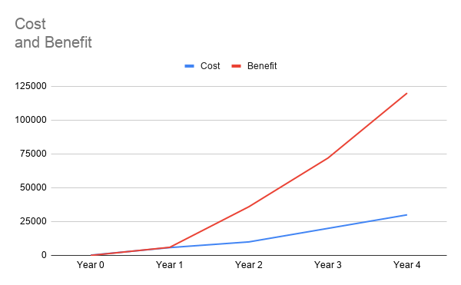

**Use Case Diagram**

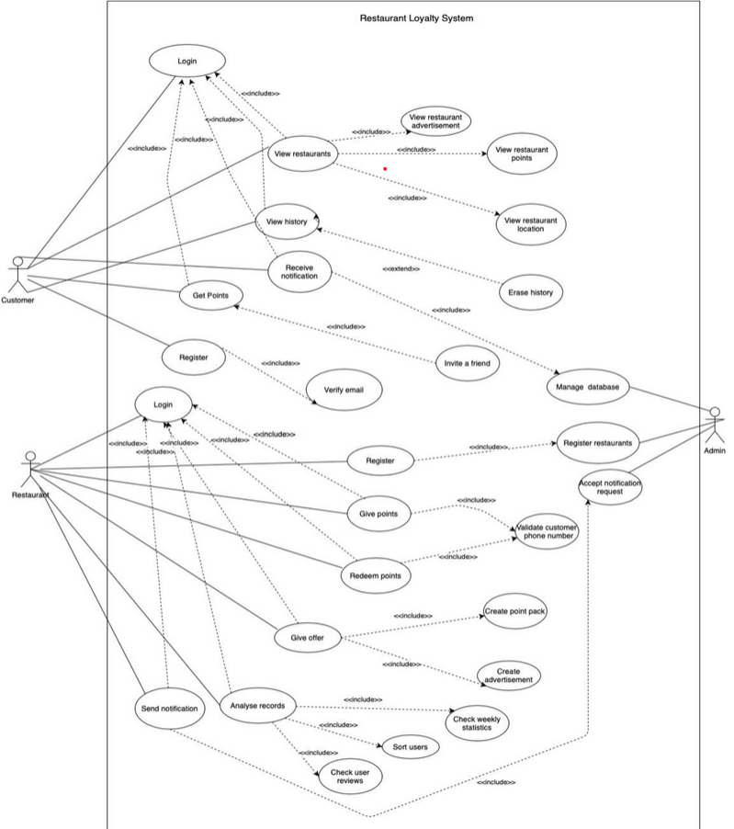

**DataFlow Diagram**

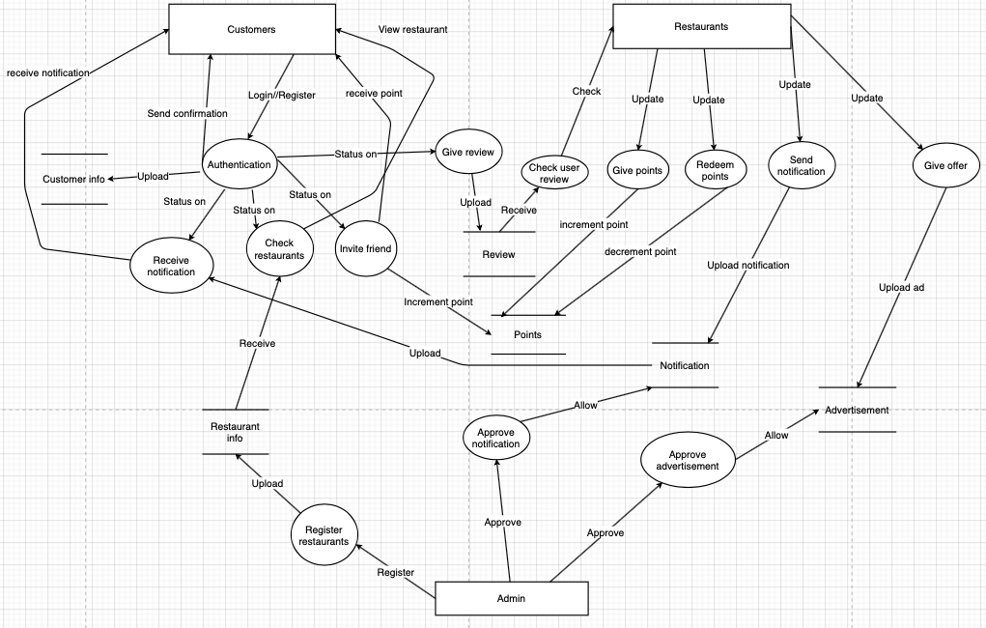**Window Navigation Diagram-** **User Version**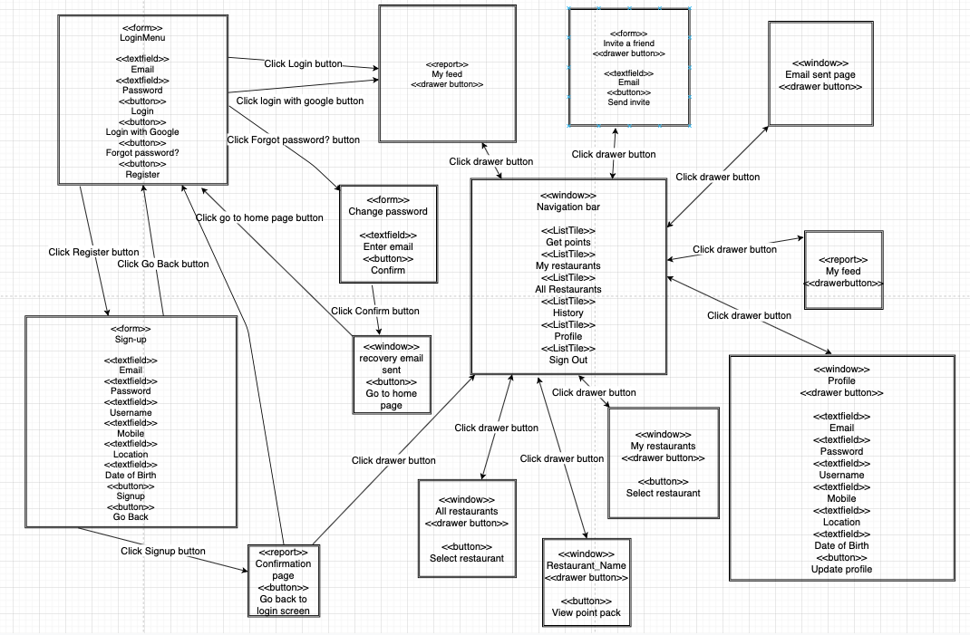

**Window Navigation Diagram- Restaurant Version**

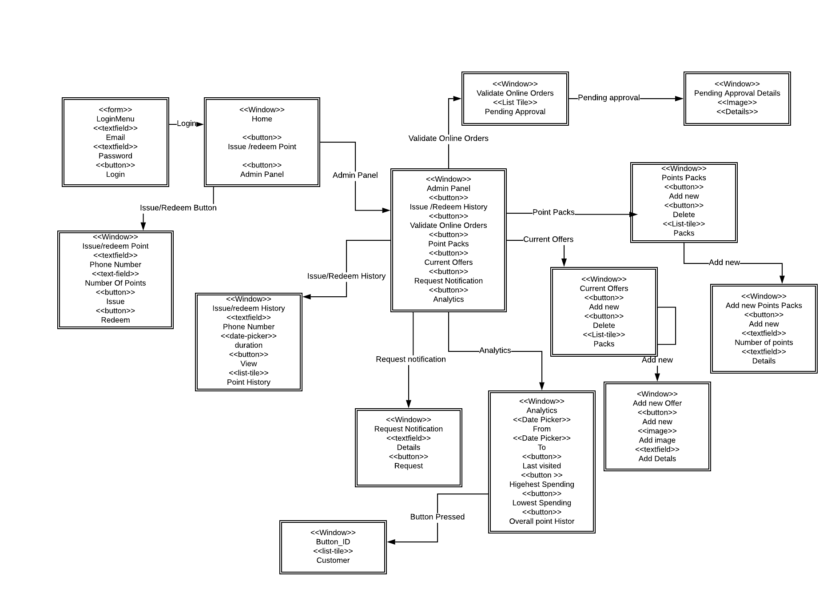

**ER-Diagram**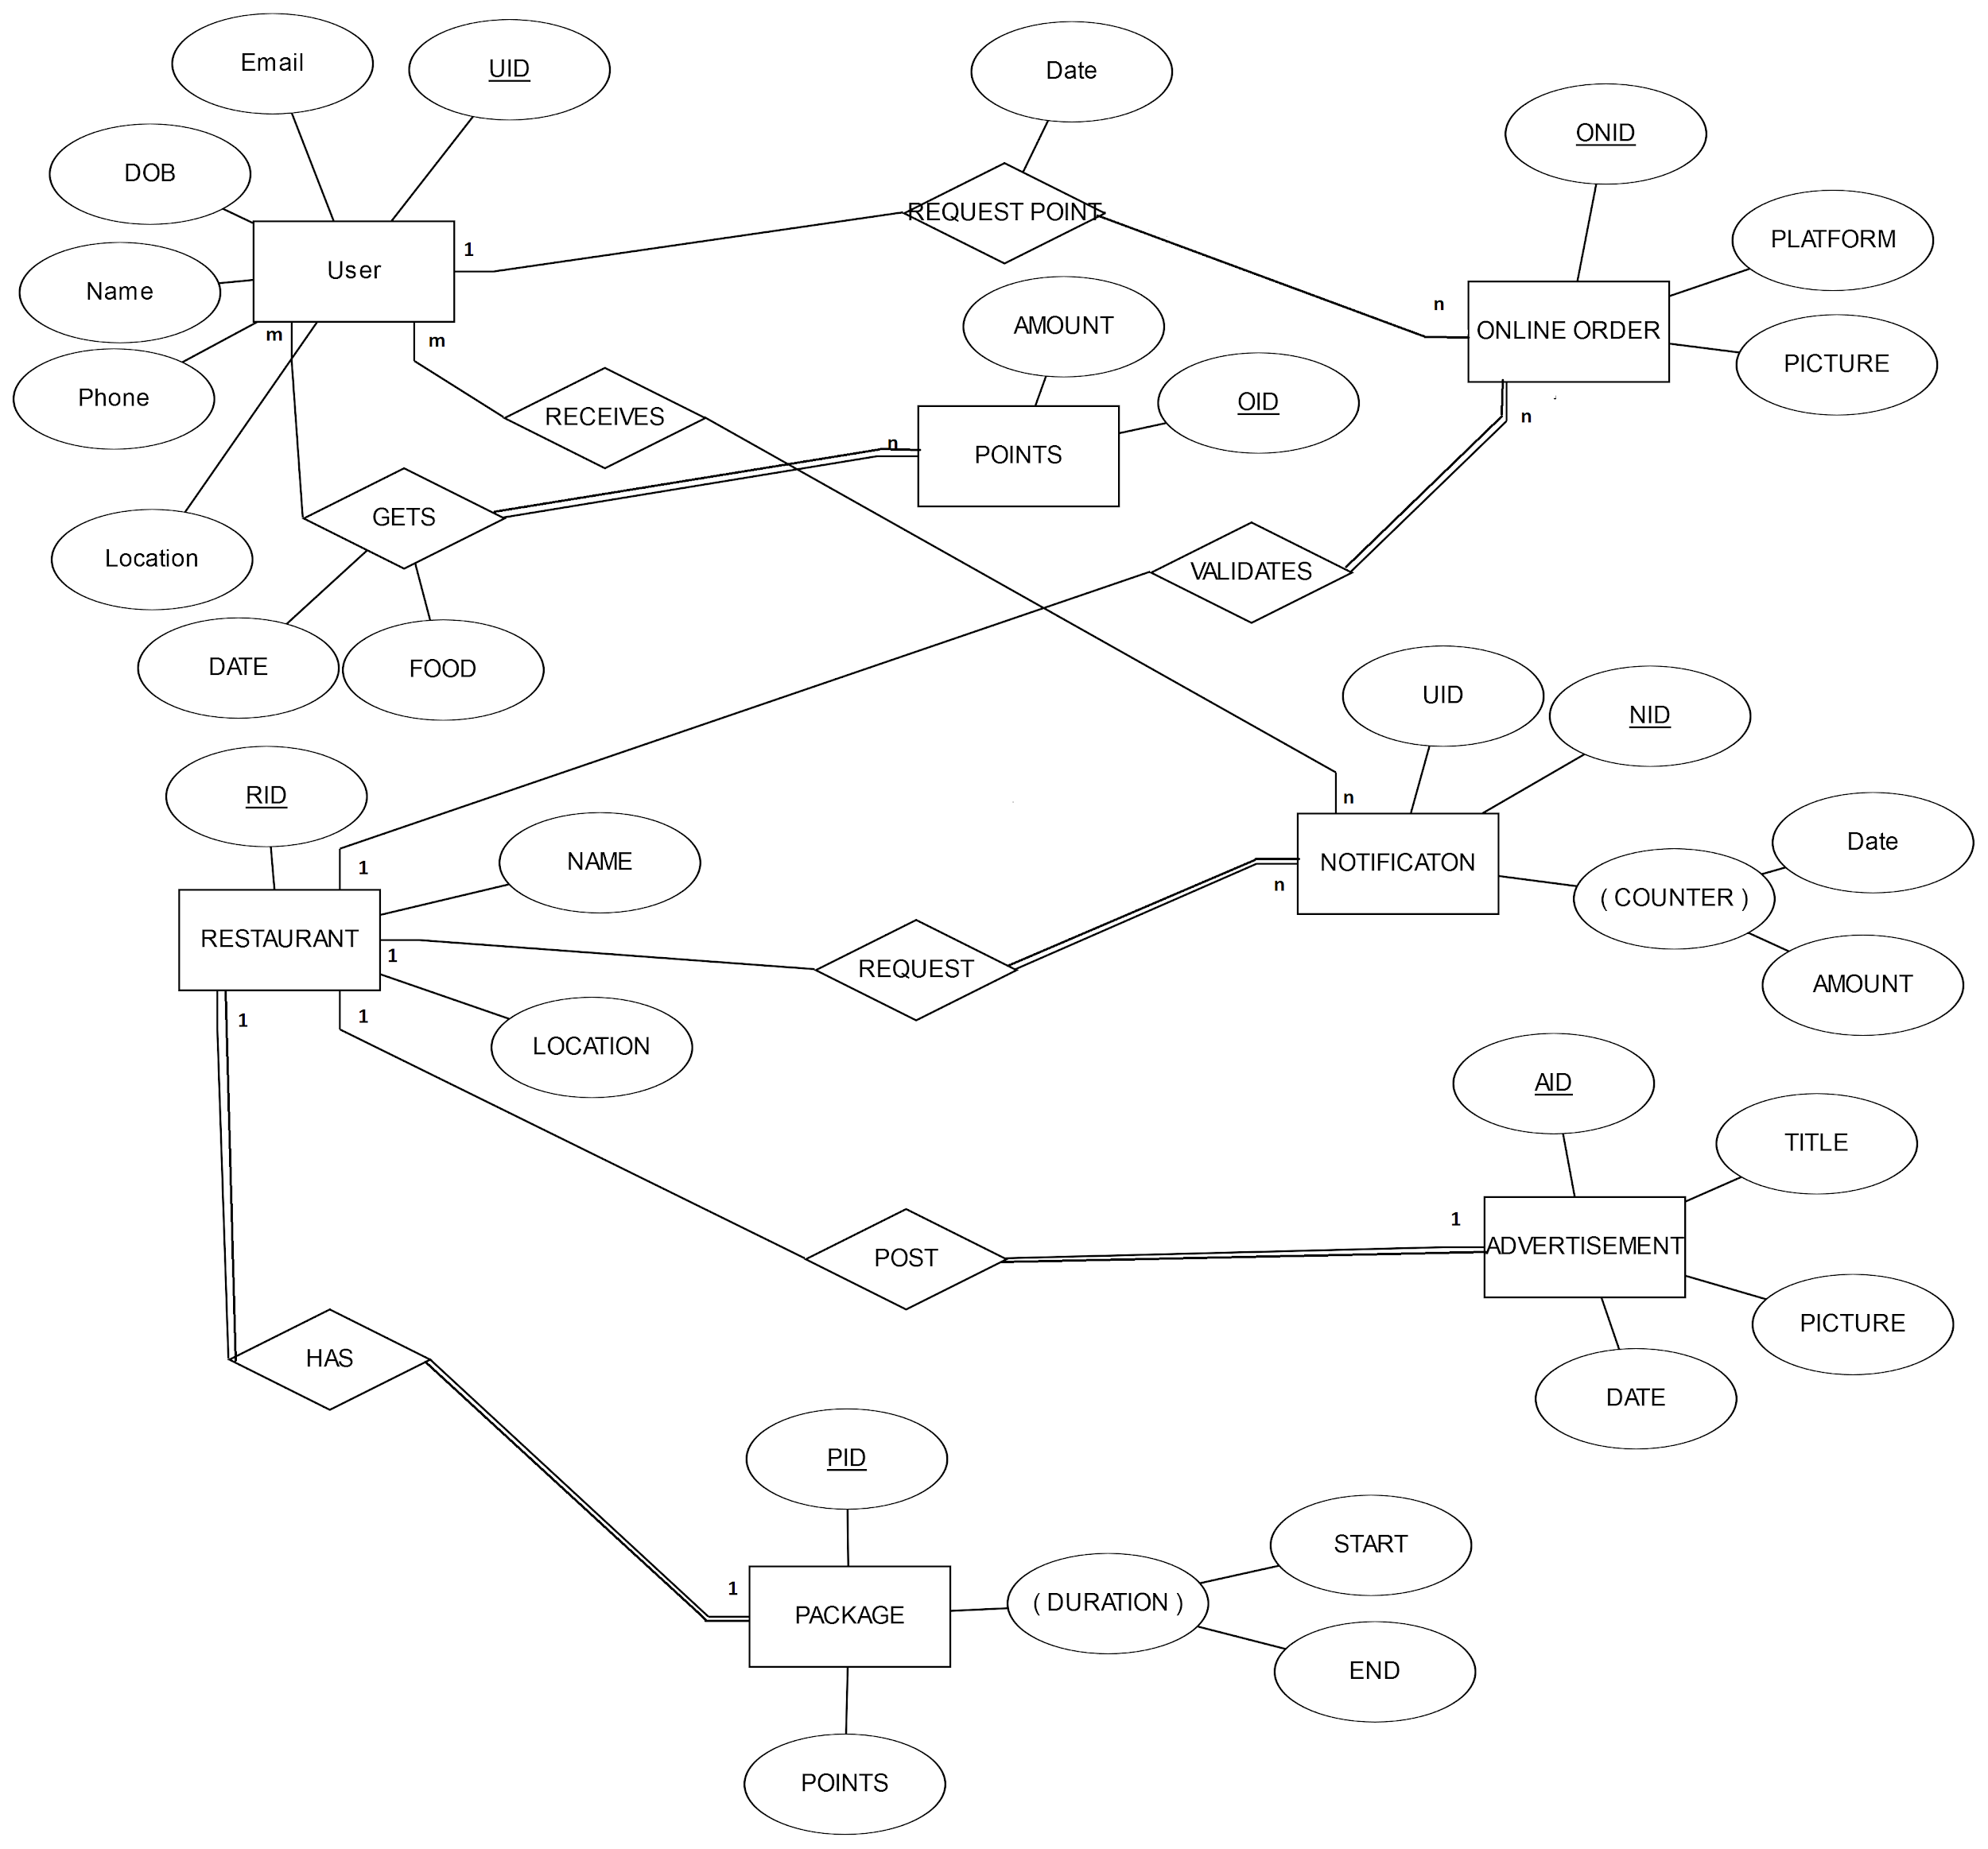

**Schema diagram**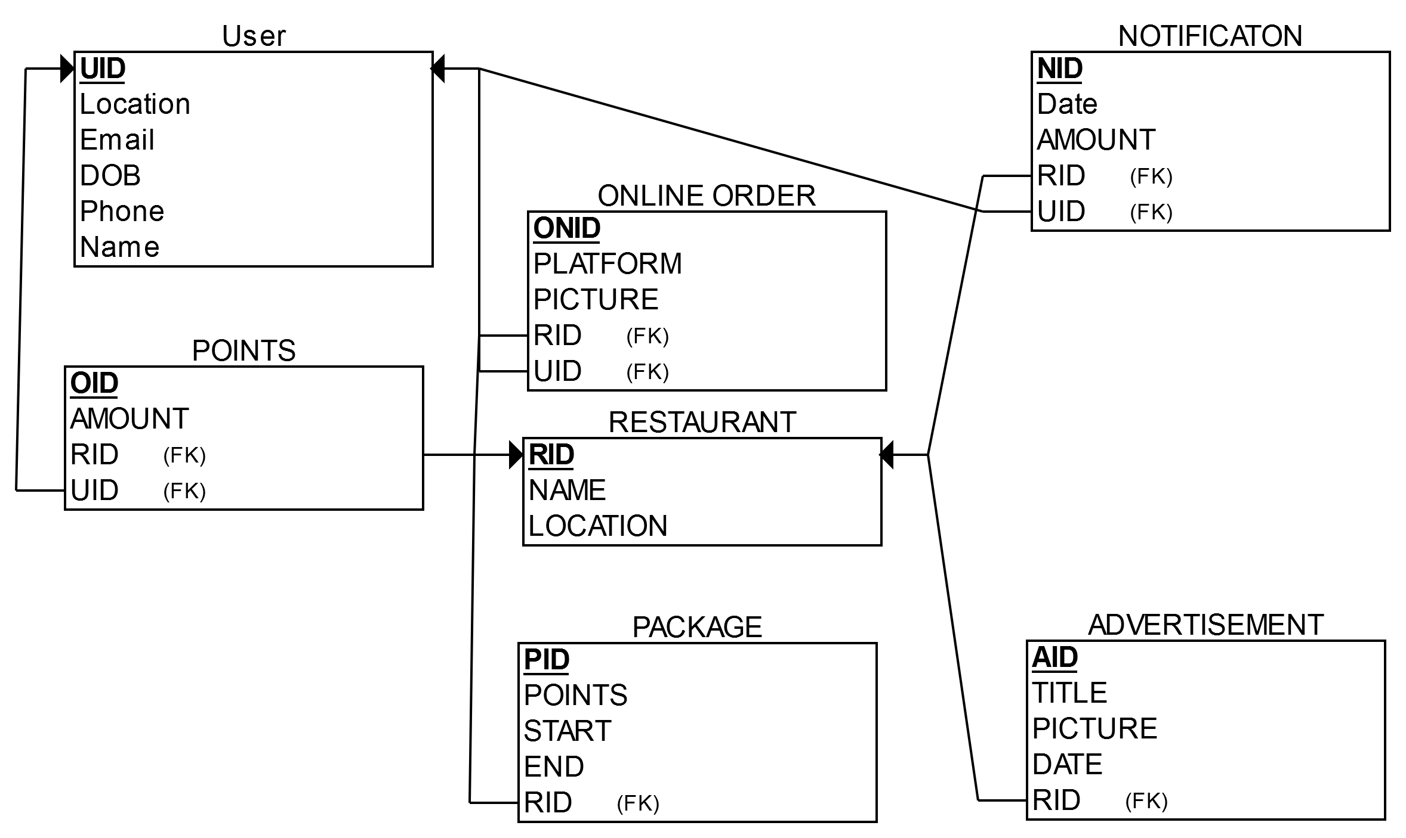

**Drawbacks of the System**

* Automated notification is not supported
* No Web version to access from browsers
* No customer-care system to receive complaints

**Future Improvements**

We will introduce the loyalty system to other fields such as lifestyle, health and fitness, entertainment etc. We will also try to add an appointment system and a chat system which will allow users to communicate with other users and restaurants.

**Conclusion**

This project’s goal is to help restaurants increase sales by creating the tools to reach customers by a customer loyalty program using mobile application which will help them to track customer behavior by analyzing data and run successful loyalty programs catered to every restaurant's specific needs. The platform will also provide a feed where restaurants will be able to post advertisements.